Personnel responsible:
All employees, visitors, and contractors are responsible for being aware of and respecting Overhead Work.
When entering different areas of the plant, be aware of work being done around you and any safety precautions that may be needed in that area.

Safety equipment:
- Personal Protective Equipment (safety glasses, steel toe shoes, and appropriate safety apparel) is to be worn at all times
- Hard Hats are to be worn in designated areas and may be obtained from Maintenance and/or Safety Department.
- Warning signs, Warning tape, or barricades are to be used to designate areas where Overhead Work safety is to be observed.

Procedure
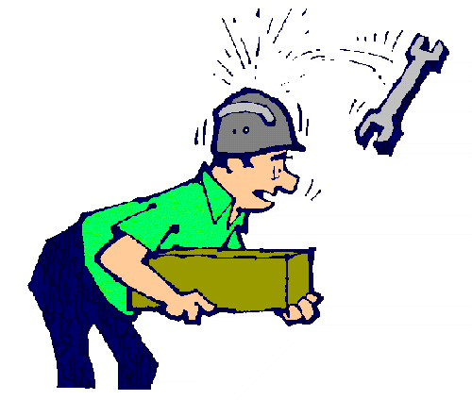
Special precautions shall be taken when overhead work is performed. If overhead construction, maintenance or general work is being done where materials, tools or product can fall, cordon off the area and post warning signs to prevent people from entering the danger zone. If the zone must be entered, a hard hat shall be worn. When people are working together, such as one person on a ladder/scaffold and the other person at the base of the ladder/scaffold, the person on the ladder/scaffold should secure all tools and materials so they will not fall and hit the person below. The person working below shall wear a hard hat, to prevent serious injury.

TRAINING DOCUMENTATION

 | EMPLOYEE | TITLE | SIGNATURE | DATE
1
2
3
4
5
6
7
8
9
10
11
12
13
14
15
16
17
18

Revision  Number | Revision  Date | Revision  Author | Revision Description
00 | 10/30/07 | JB | -New Document
01 | 10/10/11 | SL | - Updated whole procedure

